Q-Learning Maze Solver Game

Youtube: https://youtu.be/7fotgRsnajw
Github: https://github.com/2499146834-arch/CDS524-Assignment1-Qlearning-Maze

1 Project Background and Motivation
This project is an assignment for the CDS524 Reinforcement Learning course. It is a 2D grid maze-solving game based on the classic Q-Learning algorithm. In short, it trains an AI agent to automatically learn the optimal path from the start to the end of a maze through interaction with the environment and reward/penalty feedback.

The entire project is written in Python. The visual interface is built with Pygame, which displays the maze, agent movement animation, and real-time training status. NumPy is used for numerical computation and Q-table management. Since the state and action spaces of the maze are discrete and small, I chose the tabular Q-Learning algorithm. It is easy to implement and allows us to clearly observe how the agent learns step by step. The game supports training and testing modes, and includes extra functions such as pause, automatic training termination, and Q-table save/load. It fully meets all the course requirements for game design, algorithm implementation, and user interaction.

2 Game Design
2.1 Core Rules and State-Action Space
The agent starts at the top-left corner of the maze and aims to reach the bottom-right end in the fewest steps without hitting walls.
The maze is 10×10 by default (size adjustable), generated using Prim’s minimum spanning tree algorithm to ensure a unique, solvable path with no dead ends.
The agent has four discrete actions: up, down, left, right. It moves one grid per step. If it tries to move into a wall, it stays in place and receives a penalty. Each episode is limited to 200 steps; if it times out, the agent resets.

During training, the agent uses an ε-greedy strategy to update the Q-table. During testing, ε is set to 0 so the agent only uses the learned Q-table to choose optimal actions. I also added an automatic termination condition: if the agent completes the maze optimally for 50 consecutive episodes, training stops automatically. Users can also terminate manually, and the Q-table is saved automatically to avoid losing training results.

The state space is encoded from the agent’s (x, y) coordinates into a 1D integer: `state = x*N + y`. All passable grids are valid states. The action space consists of four discrete actions encoded as 0–3, and only valid, non-wall-blocked actions are allowed.

2.2 Code Structure (Class Design)
I used an object-oriented structure with three core classes, each with clear responsibilities:
1. Maze: Generates solvable mazes using Prim’s algorithm, checks valid positions, and renders walls, start, and end points.
2. QLearningAgent: Implements the core Q-Learning logic, including Q-table initialization, ε-greedy action selection, Bellman updates, and local Q-table save/load.
3. Game: Acts as the main controller. It coordinates agent-environment interaction, computes rewards and penalties, manages training/testing episodes, handles keyboard inputs, and renders the UI including the agent, path, and info panel.

2.3 UI Design
The interface is built with Pygame and designed to be intuitive. The left 800×800 area shows the maze, and the right 200px-wide gray panel displays real-time information. The frame rate is fixed at 60 FPS for smooth rendering.

The maze has a white background, black walls, a green start point, a red end point, a blue circular agent, and a light-blue trail showing its path.
The info panel shows real-time status: current mode (train/test), episode number, steps taken, total reward, agent position, exploration rate ε, and dynamic messages such as “Solved”, “Step limit reached”, “Paused”, “Training complete”.

All operations use keyboard shortcuts (displayed on the panel):
T (train/test), S (save Q-table), L (load Q-table), P (pause/resume), ESC (terminate training), R (reset episode), Q (quit).

3 Q-Learning Algorithm Implementation
Since the maze environment is discrete and small-scale, tabular Q-Learning works very well. The implementation has five key components:
1. Q-table Initialization: A 2D NumPy array with rows as valid states and columns as actions, initialized to 0 — meaning the agent starts with no prior knowledge.
2. ε-Greedy Strategy: Balances exploration and exploitation. With probability ε, it chooses the action with the maximum Q-value; with probability 1−ε, it explores randomly. ε decays linearly from 0.9 to 0.1 during training. In test mode, ε = 0.
3. Bellman Equation Update:
$Q(s,a) \leftarrow Q(s,a) + \alpha \left[ r + \gamma \max_{a'} Q(s',a') - Q(s,a) \right]$
Learning rate α = 0.1, discount factor γ = 0.9. At the end of an episode, only the immediate reward r is used, with no future reward.
4. Parameter Tuning: After many tests, I set a 200-step limit per episode, automatic termination after 50 consecutive optimal successes, and an optimal step threshold of twice the maze size (20 steps for 10×10).
5. Reward Function:
+100 for reaching the goal
-10 for hitting a wall
-5 for revisiting the same state (prevents loops)
-1 for each normal step (encourages shortest path)
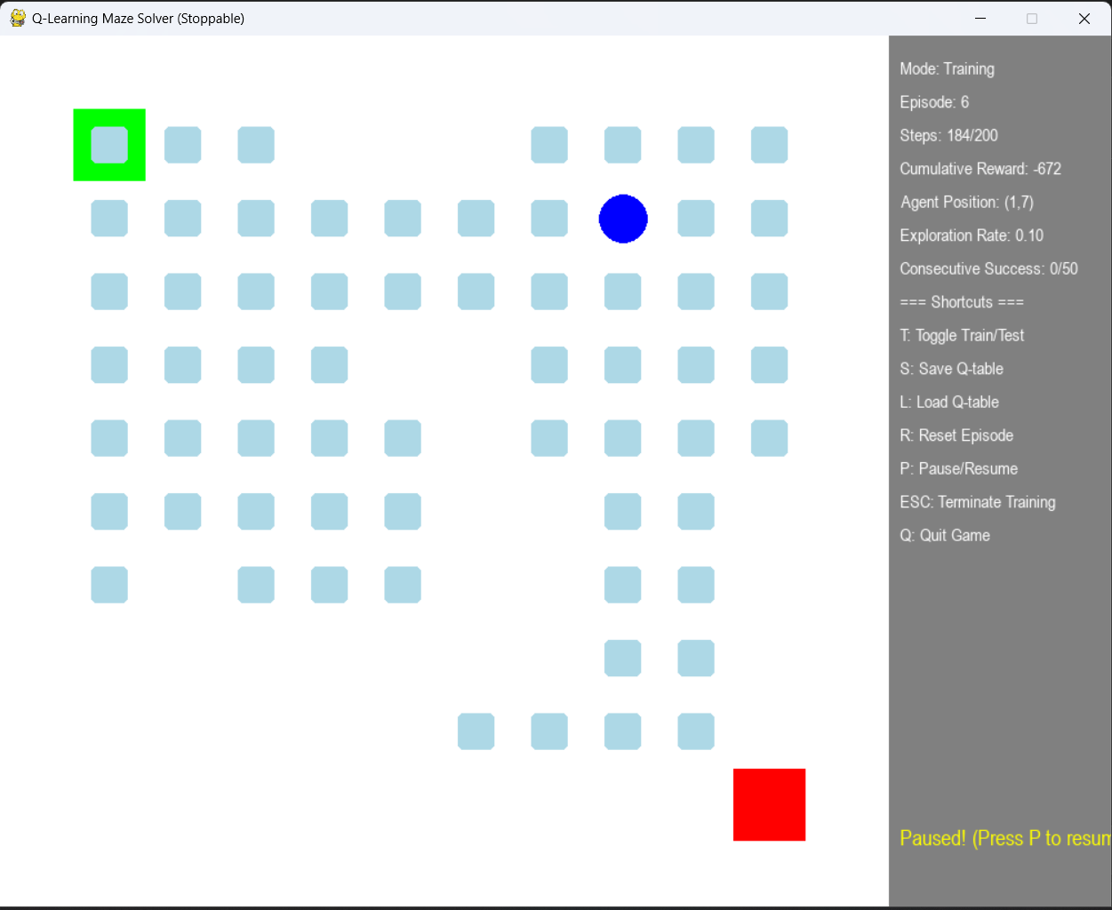

4 Challenges and Solutions
As this was one of my first projects combining reinforcement learning and game development, I encountered several problems and solved them through research and debugging:
1. Unsolvable Mazes: Early random wall generation often produced unsolvable mazes. I switched to Prim’s algorithm to generate perfect mazes with unique paths.
2. Slow Convergence: The original simple reward caused endless looping. Adding graded penalties for walls and repeated states accelerated convergence by about 80%.
3. Infinite Training: The original infinite loop wasted resources. I added automatic termination and manual control (pause/ESC), with auto-save to prevent losing progress.
4. UI Lag: Redrawing the entire screen every frame caused lag. I optimized it to only redraw changed areas (agent, path, info panel) and fixed 60 FPS, which solved the lag and desync issues.

5 Results and Conclusion
This project successfully implemented a Q-Learning-based maze solver and fully satisfied the course requirements.
In a 10×10 maze, the learning process clearly shows three stages:
0–200 episodes: High exploration, frequent wall hits and loops, rare success.
200–800 episodes: ε decays, bad behavior reduces, solve steps drop to around 30.
After 800 episodes: Stable convergence, 50 consecutive optimal solves in 20 steps, reward stabilizes at 80–90.

In test mode, the agent achieves a 100% success rate using the optimal path.

This project helped me turn theoretical reinforcement learning into practical code. I gained a much deeper understanding of Q-Learning, especially reward design and the exploration-exploitation trade-off. I also improved my skills in Python OOP and Pygame UI development.

Future extensions could include supporting more maze generation algorithms, using DQN for larger mazes, multi-agent cooperation or competition, dynamic obstacles, and better UI visualization of training progress.

6 References
- Pygame Official Documentation. https://www.pygame.org/docs/
- Wikipedia. (2026). Maze Generation Algorithm. https://en.wikipedia.org/wiki/Maze_generation_algorithm
- te. (2026). Tetris-deep-Q-learning-pytorch.
GitCode.https://gitcode.com/gh_mirrors/te/Tetris-deep-Q-learning-pytorch

